Macromolecular X-ray Crystallography and Automated Biological Calorimetry Facilities Newsletter Fall 2021
- Installation of new NIH 1S10OD028589-01 funded X-ray instrumentation for crystallography (right port) and biological small angle X-ray scattering (left port) complete and exciting research underway
- NIH S10 OD030490-01 funded Wyatt Technology SEC – MALS installation planned October 2021
- NIH SEPA grant funded SHAPE MATTERS summer workshop, a success
- Recent publications reflects productivity
- Contact Dr. Neela Yennawar, facility director or Julia Fecko, research technologist for scheduling and user training. For small molecule and protein X-ray crystallography, contact Dr. Hemant Yennawar.
1. NIH 1S10OD028589-01 grant brings upgrades for both small and macromolecular X-ray crystallography (right port) and bioSAXS (left port)

Brand New! BioSAXS-2000^{nano} 2D-Kratky system
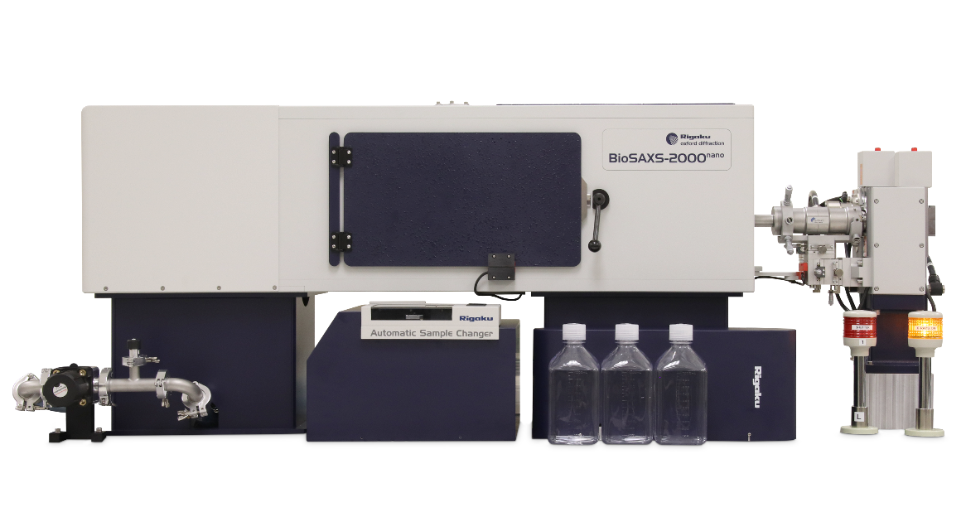
We now have built a novel capability for biological small angle X-ray scattering (SAXS) with the BioSAXS-2000^{nano} 2D-Kratky system. SAXS technique has the advantage of determining a low-resolution true solution-state structure with a fast turnaround time. The Rigaku components are state-of-the-art, have a higher X-ray flux and good sensitivity. Solution structure of protein complexes from coronaviruses to anaerobic metalloenzymes are being carried out.
X-ray generator - Rigaku MicroMax-007HF X-ray generator - The MicroMax 007HF is Rigaku's standard lab rotating anode microfocus source and is the latest generation of the original microfocus rotating anode generator. The MicroMax 007HF is current and reliable and is the one component that has been retained from previous instrumentation.

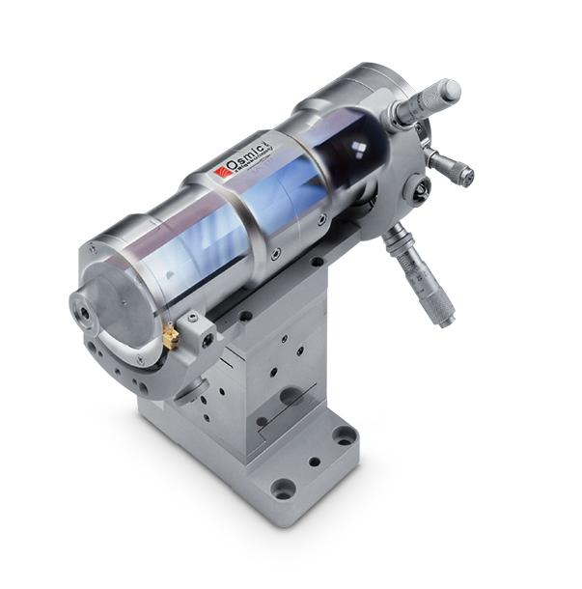
Optics - Varimax-VHF optics – New updates include the Varimax-VHF optics with higher flux suitable for small sized crystals of around 40μm. The new Varimax VHF optics has a five-fold higher fluence, two times higher divergence and yields a 20% brighter X-ray flux. The finer beam lowers the background scatter improving signal-to-noise ratio. This modification yields much better results during X-ray crystal screening and X-ray data collection of tiny crystals, and does not adversely affect experiments with crystals of larger size.

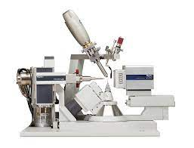
Goniometer- Universal 4-circle kappa goniometer – Also updated is the universal four-circle kappa goniometer for efficient data collection. Features include new motors allowing it to move twice as fast as its predecessor and with very high accuracy, a symmetrical theta range for flexibility in gathering data in reciprocal space, a new beam stop holder design to allow the detector to be positioned nearer to the sample and a telescoping theta arm for long detector distances.
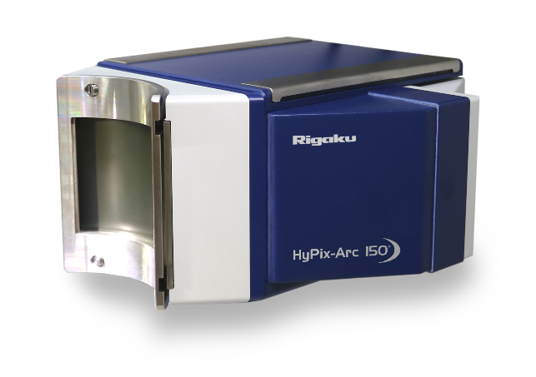
Detector- Rigaku HyPix-Arc 150° - New detector with Hybrid photon counting (HPC). The new HPC detectors are shutterless, large area, highly sensitive detectors that enable fast data collection from weakly diffracting crystals, address samples with large unit cells and enable accurate intensity measurement of Friedel pairs (necessary for SAD and chirality experiments). Small molecule X-ray crystal structures can be determined in a matter of minutes and protein crystal structures with homology in hours.

Cryo-unit- Oxford Cryo-stream – used for cooling crystals during data collection to -180°C.

2. NIH S10 grant funded SEC-MALS installation in Oct 2021

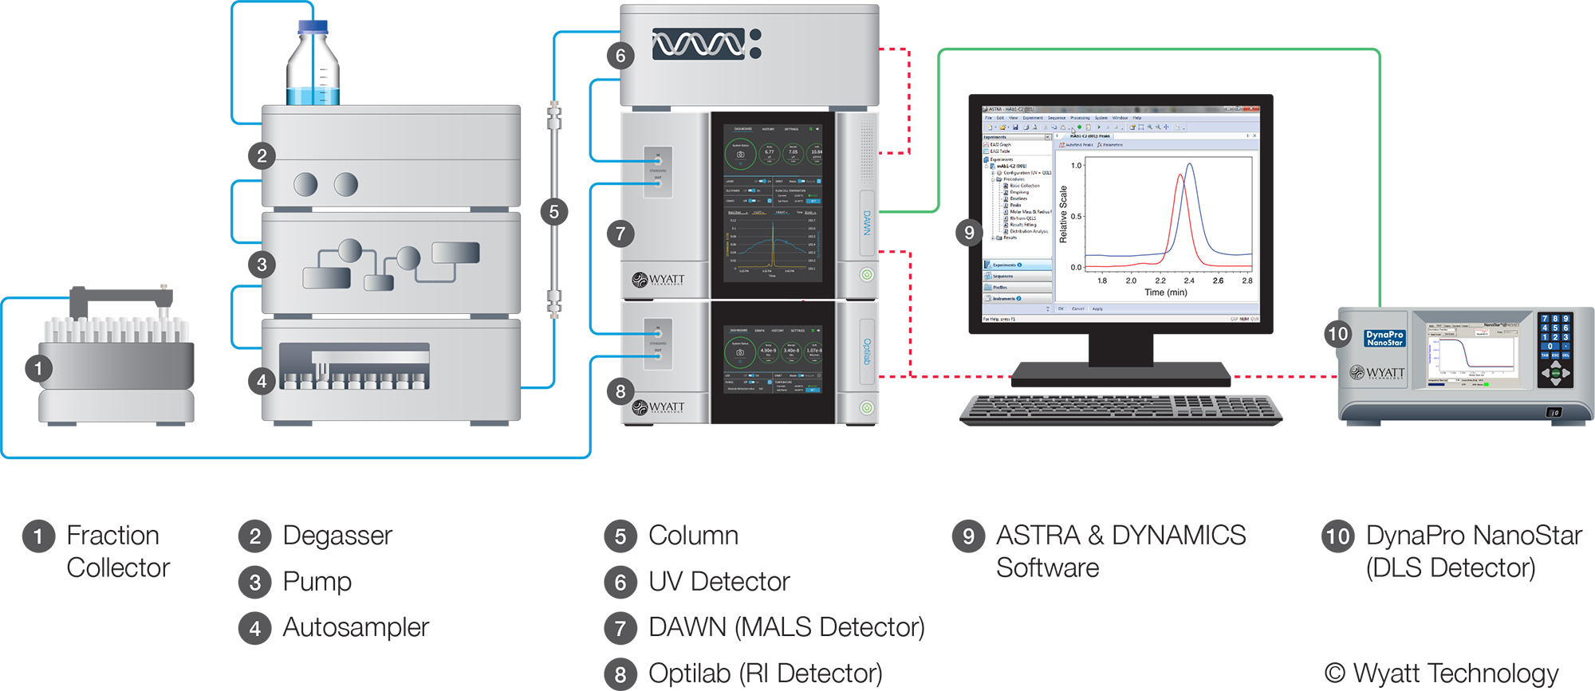
Our latest NIH funded grant has enabled purchase of a Wyatt Technology DLS multi angle light scattering (MALS) equipment in-line with size exclusion chromatography (SEC). This will help with accurate size, molecular weight, and stoichiometry data on a host of disease related biomolecules, viral and bacterial proteins, motor, nucleosome and intrinsically disordered proteins, nucleic acids, liposomes and their complexes.

3. We welcome high school science teachers to new SHAPE MATTERS instructional summer course

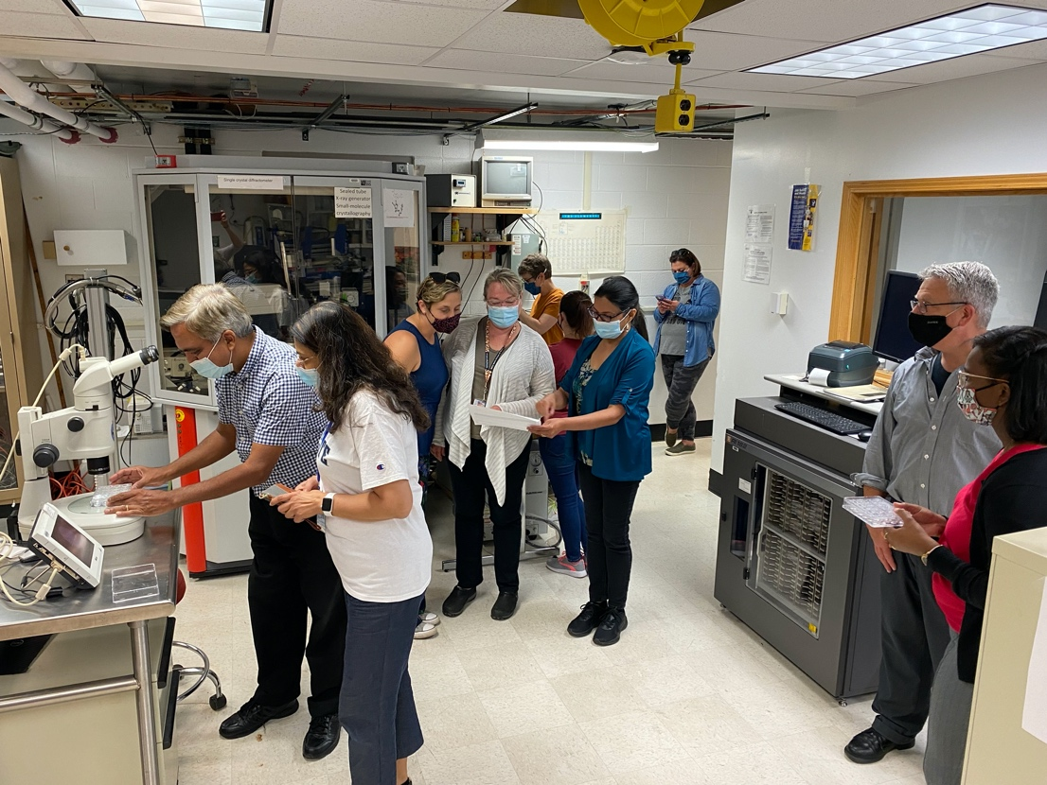
SHAPE MATTERS, an NIH SEPA funded project designed to engage high school science teachers in a rigorous professional development experience, will impact hundreds of rural students per participating teacher. The team launched this summer a professional development experience for teachers to increase their knowledge of the scientific practices involved in molecular biology research. Teachers examined a series of molecular stories of current PSU research projects and worked directly with a research mentor. They developed a 3-dimensional model of the relevant molecule and presented a new molecular story. They are creating a biomolecular science curriculum within central Pennsylvania schools in close collaboration with the SHAPE MATTERS team.

4. Facility co-authored publications since 2018

- Esakova, OA, Grove, TL, Yennawar NH, Arcinas AJ, Almo SC and Squire J. Booker (2021), Structural basis for tRNA methylthiolation by the radical S-adenosylmethionine enzyme MiaB, Nature, accepted.
- Chatterjee D, Wittmeyer K, Lee TF, Cui J, Yennawar NH, Yennawar HP, Meyers BC, Chopra S. (2021) Maize unstable factor for orange1 is essential for endosperm development and carbohydrate accumulation. Plant Physiol. Apr 26: kiab183. doi: 10.1093/plphys/kiab183.
- Bansia H, Mahanta P, Yennawar NH, Ramakumar S. (2021) Small glycols discover cryptic pockets on proteins for fragment-based approaches. J Chem Inf Model., 61(3):1322-1333.
- Kim SA, Zhu J, Yennawar N, Eek P, Tan S, (2020) Crystal structure of the LSD1/CoREST histone demethylase bound to its nucleosome substrate. Mol Cell. May 4: S1097-2765(20)30261-6.
- Dayna C. Patterson, Myrhh Perez Ruiz, Hyerin Yoon, Johnnie A. Walker, Jean-Paul Armache, Neela H. Yennawar and Emily E. Weinert (2021), Differential ligand-selective control of opposing enzymatic activities within a bifunctional c-di-GMP metabolic protein, Proc Natl Acad Sci U S A. 2021 Sep 7;118(36):e2100657118.
- Yifan Xu, Rui Zu, Neela H. Yennawar, Venkatraman Gopalan, Robert J. Hickey (2021), Thermo-responsive second harmonic generation in co-crystalline polymer films, ACS Macro Letters, accepted.
- Dayna C. Patterson, Yilin Liu, Sayan Das, Neela H. Yennawar, Jean-Paul Armache, James R. Kincaid, and Emily E. Weinert1, (2021), Heme edge residues modulate non-equivalent hemes with unusually high midpoint potentials within a bifunctional homo-dimeric sensor protein, Biochemistry, submitted.
- Jungjin Yoon, Yuchen Hou, Abbey Marie Knoepfel, Dong Yang, Tao Ye, Luyao Zheng, Neela Yennawar, Mohan Sanghadasa, Shashank Priya, Kai Wang (2021), Bio-inspired strategies for next-generation solar mobile power sources, The royal society of chemistry, accepted.
- Barber GD, George C, Hogg K, Johnstone ST, Pacheco CN, Yennawar HP, Van Der Sluys WG. (2020) Hydrothermal Synthesis and Structure of a Dinuclear Molybdenum(III) Hydroxy Squarate with a Mo-Mo Bond. ACS Omega. Feb 28;5(9):4668-4672. doi: 10.1021/acsomega.0c00083. PMID: 32175513; PMCID: PMC7066654.
- Hoelzel CA, Hu H, Wolstenholme CH, Karim BA, Munson KT, Jung KH, Zhang H, Liu Y, Yennawar HP, Asbury JB, Li X, Zhang X. (2020) A General Strategy to Enhance Donor-Acceptor Molecules Using Solvent-Excluding Substituents. Angew Chem Int Ed Engl.2020 Mar 16;59(12):4785-4792. doi: 10.1002/anie.201915744. Epub Feb 3.PMID: 31922642.
- Yennawar HP, Thompson EN, Li J, Silverberg LJ. (2019) Crystal structures of two solvated 2-aryl-3-phenyl-2,3-di-hydro-4<i>H</i>-pyrido[3,2-<i>e</i>][1,3]thia-zin-4-ones. Acta Crystallogr E Crystallogr Commun. Oct 22;75(Pt11):1689-1693. doi: 10.1107/S2056989019013781. PMID: 31709091; PMCID:PMC6829726.
- Leamy KA, Yamagami R, Yennawar NH, Bevilacqua PC. (2019) Single-nucleotide control of tRNA folding cooperativity under near-cellular conditions. Proc Natl Acad Sci U S A Nov 12;116(46):23075-23082. doi: 10.1073/pnas.1913418116. Epub 2019 Oct 30. PMID: 31666318; PMCID: PMC6859320.
- Yennawar HP, Hess AR, Allcock HR. (2019) Crystal structures of three hexakis-(fluoroar-yloxy)cyclo-triphosphazenes. Acta Crystallogr E Crystallogr Commun. Sep 27;75(Pt 10):1525-1530. doi: 10.1107/S2056989019012933. PMID: 31636987; PMCID: PMC6775729.
- Yennawar HP, Peterson SD, Silverberg LJ. (2019) Crystal structures of two isomeric 2-aryl-3-phenyl-1,3-thia-zepan-4-ones. Acta Crystallogr E Crystallogr Commun. Jul 26;75(Pt 8):1270-1273. doi: 10.1107/S2056989019010429. PMID: 31417805; PMCID: PMC6690465.
- Esakova OA, Silakov A, Grove TL, Warui DM, Yennawar NH, Booker SJ.(2019) An
Unexpected Species Determined by X-ray Crystallography that May Represent anIntermediate in the Reaction Catalyzed by Quinolinate Synthase. J Am Chem Soc. Sep 11;141(36):14142-14151. doi: 10.1021/jacs.9b02513. Epub 2019 Aug 26. PMID: 31390192; PMCID: PMC7029380.
- Van Buiten CB , Yennawar NH , Pacheco CN , Hatzakis E , Elias RJ.(2019). Physicochemical interactions with (-)-epigallocatechin-3-gallate drive structural modification of celiac-associated peptide α<sub>2</sub>-gliadin (57-89) at physiological conditions. Food Funct. May 22;10(5):2997-3007.
doi: 10.1039/c9fo00553f. PMID: 31086895.
- Yennawar HP, Tierney J, Cannon KC. (2019) Crystal structure of a 1:1 adduct of tri-phenyl-tin chloride with 3-cyclo-hexhyl-2-phenyl-1,3-thia-zolidin-4-one. Acta Crystallogr E Crystallogr Commun. Feb 8;75(Pt 3):338-341. doi: 10.1107/S2056989019001592. PMID: 30867944; PMCID: PMC6399697.
- Rose HR, Maggiolo AO, McBride MJ, Palowitch GM, Pandelia ME, Davis KM,
Yennawar NH, Boal AK. (2019) Structures of Class Id Ribonucleotide Reductase Catalytic Subunits Reveal a Minimal Architecture for Deoxynucleotide Biosynthesis. Biochemistry. Apr 9;58(14):1845-1860. Doi 10.1021/acs.biochem.8b01252 PMID: 30855138; PMCID: PMC6456427.
- Yennawar HP, Silverberg LJ, Cannon K, Gandla D, Kondaveeti SK, Zdilla MJ, Nuriye A. (2018) Crystal structures of two 1,3-thia-zolidin-4-one derivatives featuring sulfide and sulfone functional groups. Acta Crystallogr E Crystallogr Commun. Nov 6;74(Pt 12):1695-1699. doi: 10.1107/S2056989018015098. PMID: 30574358; PMCID: PMC6281102.
- Nuriye A, Yennawar H, Cannon K, Tierney (2018) J. Crystal structures of two thia-zolidinone derivatives bearing a tri-chloro-methyl substituent at the 2-position Acta Crystallogr E Crystallogr Commun. Sep 28;74 (Pt 10):1509-1512. doi: 10.1107/S2056989018013257. PMID: 30319812; PMCID: PMC6176436.
- Yennawar HP, Moyer QJ, Silverberg LJ. (2018) Crystal structure of meso-3,3'-(1,4-phenyl-ene)bis-(2-phenyl-2,3,5,6-tetra-hydro-4<i>H</i>-1,3-thia-zin-4-one). Acta Crystallogr E Crystallogr Commun. Sep 28;74(Pt 10):1497-1499. doi: 10.1107/S2056989018013397. PMID: 30319809; PMCID: PMC6176446.
- McBrayer SK, Mayers JR, DiNatale GJ, Shi DD, Khanal J, Chakraborty AA, Sarosiek KA, Briggs KJ, Robbins AK, Sewastianik T, Shareef SJ, Olenchock BA, Parker SJ, Tateishi K, Spinelli JB, Islam M, Haigis MC, Looper RE, Ligon KL, Bernstein BE, Carrasco RD, Cahill DP, Asara JM, Metallo CM, Yennawar NH, Vander Heiden MG, Kaelin WG Jr. (2018) Transaminase Inhibition by 2-Hydroxyglutarate Impairs Glutamate Biosynthesis and Redox Homeostasis in Glioma. Cell. Sep 20;175(1):101-116.e25. doi: 10.1016/j.cell.2018.08.038. Epub 2018 Sep 13. PMID:30220459; PMCID: PMC6219629.
- Liu Y, Wolstenholme CH, Carter GC, Liu H, Hu H, Grainger LS, Miao K, Fares
M, Hoelzel CA, Yennawar HP, Ning G, Du M, Bai L, Li X, Zhang X. (2018) Modulation of Fluorescent Protein Chromophores To Detect Protein Aggregation with Turn-On Fluorescence. J Am Chem Soc. Jun 20;140(24):7381-7384. doi: 10.1021/jacs.8b02176. Epub 2018 Jun 12. PMID: 29883112; PMCID: PMC6258209.
- Yennawar HP, Bradley HG, Perhonitch KC, Reppert HE, Silverberg LJ.(2018). Spontaneous resolution and crystal structure of (2<i>S</i>)-2-(3-nitro-phenyl)-3-phenyl-2,3,5,6-tetra-hydro-4<i>H</i>-1,3-thia-zin-4-one; crystal structure of rac-2-(4-nitro-phen-yl)-3-phenyl-2,3,5,6-tetra-hydro-4<i>H</i>-1,3-thia-zin-4-one. Acta Crystallogr E Crystallogr Commun. Mar 6;74(Pt 4):454-457. doi: 10.1107/S2056989018003444. PMID: 29765744; PMCID: PMC5946966.
- Yennawar HP, Buchwalter MJ, Colburn BK, Silverberg LJ. (2018) Crystal structures of two 2,3-diaryl-2,3-di-hydro-4<i>H</i>-1,3-benzo-thia-zin-4-ones. Acta Crystallogr E Crystallogr Commun. Feb 20;74(Pt 3):363-366. doi:
10.1107/S2056989018002049. PMID: 29765724; PMCID: PMC5947804.
- Leamy KA, Yennawar NH, Bevilacqua PC.(2018) Molecular Mechanism for Folding Cooperativity of Functional RNAs in Living Organisms. Biochemistry. May 22;57(20):2994-3002. doi: 10.1021/acs.biochem.8b00345. Epub 2018 May 7. PMID: 29733204; PMCID: PMC6726375.

Facility acknowledged in publications

- Energy and Enzyme Activity Landscapes of Yeast Chorismate Mutase at Cellular Concentrations of Allosteric Effectors. Gorman SD, Boehr DD. (2019) Biochemistry. 58(39):4058-4069.
- Structural basis for activation of SAGA histone acetyltransferase Gcn5 by partner subunit Ada2 Jian Sun, Marcin Paduch, Sang-Ah Kim, Ryan M. Kramer, Adam F. Barrios, Vincent Lu, Judy Luke, Svitlana Usatyuk, Anthony A Kossiakoff , Song Tan (2018) PNAS. 115 (40) 10010-10015
- Crystalline nanocellulose/lauric arginate complexes. Chi K, Catchmark JM. (2017) Carbohydr Polym. Nov 1;175:320-329. doi: 10.1016/j.
- Computational de novo Design of Antibodies binding to a Peptide with High Affinity. Poosarla VG, Li T, Goh BC, Schulten K, Wood TK, Maranas CD. (2017) Engineering Science of Biological Systems Biotechnology and Bioengineering DOI 10.1002/bit.26244
- Effects of Histidine and Sucrose on the Biophysical Properties of Monoclonal Antibody. Baek Y, Singh N, Arunkumar A, Zydney AL. (2017) Pharm Res. Mar;34(3):629-639.
- Global Displacement of Canine Parvovirus by a Host-Adapted Variant: Structural Comparison between Pandemic Viruses with Distinct Host Ranges Organtini LJ, Allison AB, Lukk T, Parrish CR, Hafenstein S. (2015) J Virol. 89(3):1909-12.
- Release Kinetics of Nisin from Chitosan–Alginate Complex Films Vaishnavi Chandrasekar, John N. Coupland, and Ramaswamy C. Anantheswaran (2016) J Food Sci. 81(10):E2503-E2510.
- Cu²⁺ Binds to Phosphatidylethanolamine and Increases Oxidation in Lipid Membranes Poyton MF, Sendecki AM, Cong X, Cremer PS (2016) J. Am. Chem. Soc., 138 (5), pp 1584–1590
- Assessing Coupled Protein Folding and Binding Through Temperature-Dependent Isothermal Titration Calorimetry Sahu D, Bastidas M, Lawrence CW, Noid WG, Showalter SA. (2016) Methods Enzymol. 567:23-45
______________________________________________________________________

- Contact us

For grant writing, SAXS or protein X-ray crystallography, contact director Neela Yennawar, PhD nhy1@psu.edu 814-863-9387. For further information on ITC, DSC, CD, DLS, Phoenix crystallization robot and SEC-MALS, contact research technician, Julia Fecko jaf48@psu.edu 814-865-8068. For small or macromolecule X-ray structure determination, please contact Hemant Yennawar hpy1@psu.edu. Find us at our websites –
Automated Biological Calorimetry http://www.huck.psu.edu/facilities/calorimetry-up
X-ray Crystallography https://www.huck.psu.edu/core-facilities/x-ray-crystallography-facility

