FACILITIES, EQUIPMENT AND OTHER RESOURCES

Facilities:
The information provided below describes related instrumentation not included in the project description.
The Huck Institutes of the Life Sciences (HILS) at Penn State support research through state-of-the-art Shared Technology Facilities, with each facility having its own faculty advisory board (see the figure below). These facilities include: the X-ray Crystallography Facility, Automated Biological Calorimetry Facility, a Microscopy Facility, a Cryo-Electron Microscopy Facility, a Flow Cytometry Facility, the Genomics Core Facility, the Transgenic Mouse Facility, a High Field Magnetic Resonance Imaging facility, the CSL Behring Fermentation Facility, the Sartorius Cell Culture Facility, the Proteomics and Mass Spectrometry Facility and a Metabolomics Facility.

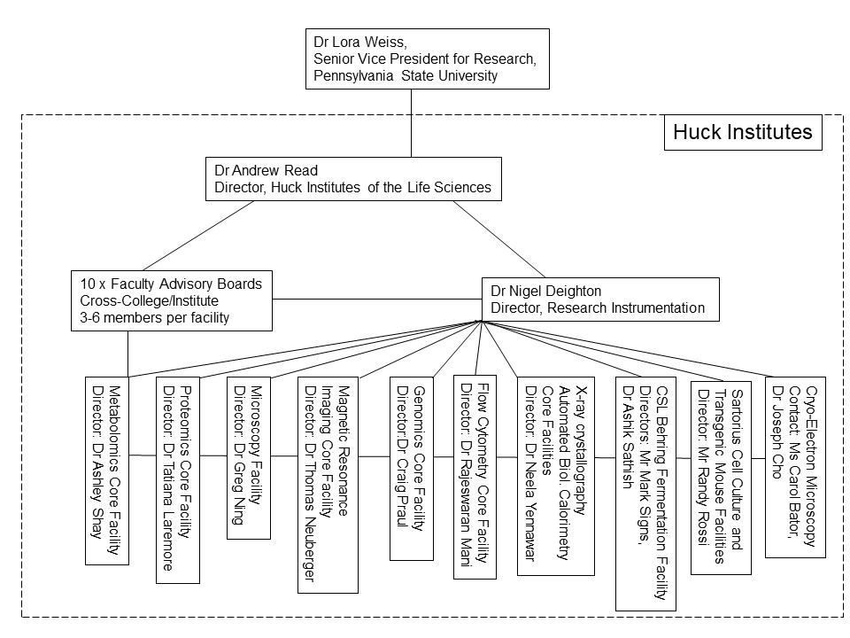

These facilities serve both faculty and students to enable research and familiarize students with highly specialized equipment and techniques. All of our facilities continue to excel, serving over 350 laboratories last year, and we shall continue to fully support their endeavors. Each Facility operates as a cost recovery center, whereby recharge to users is expected to cover maintenance and staffing costs. Actual cost recovery is approximately 70%, and as such our net investment in these core facilities is around $1.4 million per year before capital purchases, and this commitment extends to providing high quality, high visibility space to each of the cores.

Major equipment:
High Field Magnetic Resonance Imaging Center: Offers pre-clinical magnetic resonance imaging and in vivo micro computed tomography. Besides ex vivo high resolution MR microscopy and MR based material characterization, many state of the art MR techniques can be applied in vivo on e.g. rodents, birds, fish, and rabbits. Techniques include fMRI, DTI, MR spectroscopy, fat water imaging, flow imaging (angiography), cine imaging (cardio), and many more.MR detector fabrication and electrical characterization as well as animal holder construction is offered in the facility. The micro CT system is ideal for imaging rodents and smaller rabbits in vivo and ex vivo.
Available equipment includes: 2 magnetic resonance systems; an in vivo micro CT system; a network analyzer; oscilloscopes; frequency synthesizers; and several work stations with the appropriate software for image analysis.
Instrumentation includes: A Bruker 14.1 tesla vertical microimaging system with a NEO console and two Tx/Rx channels for 1H and one Tx/Rx channel for broadband imaging. A horizontal 7 Tesla Bruker 70/30 BioSpec with an Avance III HD console running Paravision 7.0 and 6.01. This system offers one Tx channel and four Rx channels for 1H and one Tx and one Rx channel for broadband imaging. The SkyScan 1176 micro CT systems offers resolutions of 35, 18 and 9 microns isotropic

Genomics: Offers next-generation library preparation and sequencing, Sanger sequencing, as well as fragment analysis. The Genomics Core also performs DNA and RNA sample QC analysis. Instrumentation includes: Illumina NextSeq 2000 and MiSeq (2), Pacific Biosciences Sequel IIe, ABI Hitachi 3730XL DNA Analyzer (2) ThermoFisher StepOnePlus and QuantStudio 12kFlex Real-time PCR Systems, Applied Biosystems QuantStudio 3D Digital PCR Instrument, Agilent Bravo and Eppendorf epMotion 5075 liquid handling robots, Sage BluePippin and Pippin Pulse, Agilent Bioanalyzer (2) and Tape Station, ThermoFisher NanoDrop and ThermoFisher Qubit.

Sartorius Cell Culture: Located in 405 Chandlee Laboratory, adjacent to the Genomics Core Facility, supports research by providing cell cultures, media, supplies and expertise on a recharge basis for more than 30 different laboratories on and off University Park campus. The Facility performs on site experimentation for researchers as well as providing cell cultures and supernatants for researchers to take to their labs for experiments. It also provides media and materials for checkout, and allows for onsite use of laminar flow hoods, incubators, bioreactors, and other equipment for researchers who are using cells provided by the Facility. Equipment will include but is not limited to the following: Sartorius Ambr 250, BioStat BDU twin with RM wave rocker, BioStat STR 50l bioreactor, Biostat Str 200L bioreactor, hollow fiber and adherent bioreactor systems, CO2 incubator rocker system, electroporator, PCR machines, cryopreservation systems and storage, IncuCyte S3 Live cell analysis system, Varioskan LUX multimode microplate reader, and multiple centrifuges, both refrigerated and room temperature. Initial downstream processing of cell culture products will also be available in this facility.

Proteomics and Metabolomics Facilities: Offer mass spectrometric analysis of synthetic compounds, polymers and biomolecules (such as proteins, peptides, oligosaccharides and oligonucleotides or their conjugates). Provides identification and quantitation of metabolites by LC-MS/MS and GC-MS, protein sample preparation and subsequent analysis by nanoflow LC ESI tandem mass spectrometry (nano LC-MS/MS). Biochemical profiling, fingerprinting, metabolomics, pulse chase experimentation (stable isotope), MS-based microorganism identification. Instrumentation includes: Thermo Orbitrap Eclipse with Electron Transfer Dissociation, Bruker UltrafleXtreme MALDI-TOF/TOF, Thermo Q-Exactive, Waters G2 Si for Hydrogen Deuterium Exchange studies, Thermo Exactive Plus, Waters Xevo TQ-S, Thermo Orbitrap Exploris 120, Thermo Orbitrap Exploris 240, Thermo TSQ Quantis Plus, AB Sciex Triple TOF 5600, Agilent 5975 GC-MS, Thermo Orbitrap Fusion Lumos (NIH 1 S10 OD021750-01A1; Patterson et al, 2017). The Metabolomics Facility also houses a Bruker NEO 600 NMR spectrometer with Bruker SampleJet autosampler (capacity >500 samples), for high throughput analysis.

CSL Behring Fermentation Facility Houses a total of 16 fermenters ranging from 500-mL to 500-liter capacities, including 7 x 500mL Applkion MiniBioreactor systems, two BioStat B – Twin units (4 x 5L), two BioStat Cplus units (2 x 30L SIP), a BioStat D-DCU twin unit (1 x 50L and 1 x 100L SIP units), and a Sartorius D-500L (500L working volume). Small scale flask studies can be accomplished through 2 x Innova 44 incubators (with one refrigerated unit) for performing flask studies. An Interscience Spiral Dilute automatic diluter and plater is available. In addition, bioprocessing applications are facilitated by a Mircofluidics M-110EH-30 and LM-20-30 microfluidizers for cell disruption. Separation and harvest of biomass are enabled by a Sharples T-1-P and AS-16 continuous flow tube bowl and a GEA-Westfalia CSA-1 disk stack centrifuges, along with a Beckman Avanti JXN26 high-capacity centrifuge. Product purification and concentration possible through an AKTA Pure 150M Fast Protein Liquid Chromatography (FPLC) system, along with Sartorius SARTOFLOW Smart and Advanced platforms for micro- and ultra-filtration. Product or material drying made possible through a Labconco FreeZone 18L system. A Thermo Vanquish HPLC system provides analytical capabilities within the facility with variable wavelength UV-VIS and RI detectors. Added capabilities to support biomass processing work provided by a UV-Vis spectrophotometer, fermentation off-gas analyzers, fermentation online glucose and lactate monitoring, and other sampling processing equipment.

Microscopy: Provides conventional transmission- and scanning electron microscopy, cryo-SEM, cryo-TEM, digitized imaging, microtomy, cryogenic sample preparation, high resolution imaging, elemental analysis, immunogold labeling, freeze-substitution, histology and immunohistochemistry. Instrumentation includes: Scanning Electron Microscope: Zeiss SIGMA VP-FESEM with Gatan 3View2, Transmission Electron Microscope: ThermoFisher Talos 200X G2. Zeiss PALM Microbeam with LCM RoboMover, Light microscopes, Accessory equipment, including a Leica HPM100 high pressure freezer. Instrumentation for microscopy includes: Leica SP8 DIVE multi-photon microscope, Olympus Fluoview 1000, Olympus Fluoview 10i, Zeiss LSM880 Airyscan Fast with PicoQuant FLIM, Keyence BZ-9000E, Zeiss AxioZoom v16 fluorescent stereo zoom microscope with ApoTom2 for optical sectioning, Olympus BX60 (digital scope), and an Olympus BX61 (materials scope). Two super resolution light microscopes (Nikon N-SIM, N-STORM and BioVision VT-iSIM) were acquired in late 2016 from a successful NSF-MRI application (Anderson et al, DBI-1625473).

Cryo-Electron Microscopy: Thermo (FEI) Talos Arctica (NIH 1 S10 OD026822-01; Hafenstein et al, 2019) and Titan Krios G3 (microscopes acquired September 2019 and June 2016 respectively). Typically data screenings are performed on the Arctica, datasets are collected on the Krios. The Krios is unique in that it combines material science functions with biological functions without compromising data collection for either one. This Krios was strategically configured to support what we are calling the “Third Revolution” in life sciences research – the translation of tools developed in the physical sciences and engineering to the life sciences. There are rich scientific opportunities at the convergence of these historically disparate disciplines and as such the Penn State Krios will retain all the functionally necessary for standard life sciences work (cryo-EM data collection, uncompromised use of the GIF and DED, tomography data collection) as well as unique functionality that is established in the physical sciences (STEM, EFTEM, EELS, Cs corrector). The combination will provide powerful new opportunities for the life sciences. More specifically the Krios is configured with: C_{S} image corrector, Gatan BioGIF 969 (EFTEM/EELS), STEM, on-axis BF/DF detector, Volta phase plate, Falcon 4 DED, and a Gatan K2 DED.
The computational architecture was designed to support fully high speed automated data collection, analysis, visualization, and long term archival storage of cryo-EM data. Data from both microscopes are moved locally at 10Gbps to high performance storage (tens to hundreds of terabytes) serving local GPU-equipped workstations (initial visualization and grid selection), central CPU and GPU compute high performance clusters configured as virtual machines (analyses), and/or parallel computer resources at Hershey College of Medicine (via a 100Gbps link). All primary and processed data is centrally archived on both intermediate and long term storage (petabyte scale).

Flow Cytometry: Instrumentation includes: Beckman Coulter MoFlo Astrios (BSL2/2+) cell sorter, Miltenyi TYTO sorter, Miltenyi VYB and BD LSR Fortessa II flow cytometers, and the EMD Millipore FlowSight imaging cytometer.

X-ray Crystallography and Automated Biological Calorimetry Core Facilities: NIH funded X-ray system (1S10RR023439-01, Yennawar, PI 2007, 1S10OD028589-01, Yennawar, PI 2020) include a Rigaku Micromax 007 X-ray generator equipped with a modern HyPix-Arc 150° Curved HPC Detector with a Universal Kappa 4-Axis Goniometer at the right port for single crystal X-ray diffraction data and a BioSAXS-2000Nano for small angle X-ray Scattering studies on the left port. The right port is configured with a VariMax-VHF high flux optics and Oxford Cryosystems COBRA for cryo-cooling the crystals. The BioSAXS port has a variable temperature, an OptiSAXS Confocal Max-Flux (CMF) SAXS Optic and an Automatic Sample Changer for high-throughput SAXS experiments. The core facility also houses a Viscotek 802 Dynamic Light Scattering instrument, an Art Robbins Instruments Phoenix protein crystallization robot, Formulatrix Rock Imager 182 with brightfield and UV microscope, Jasco J-1500 high performance Circular Dichroism spectrometer, Nikon SMZ18 stereo microscope with digital camera and a Jansi UV microscope. Also, two pieces of calorimetry instrumentation from a NSF-MRI award (DBI-0922974 to Bevilacqua, PI 2009) went into this facility, an automated isothermal titration system (AutoITC2000) and a high throughput differential scanning calorimeter (AutoCAP-DSC). A further NIH SIG augmented these with a TA Instruments Affinity ITC system (NIH 1S10OD025145-01, Yennawar, PI 2018). The successful NIH grant (1S10OD030490-01, Yennawar, PI 2021) provided the funds to purchase our state-of-the-art protein characterization equipment, an inline Wyatt SEC-MALS-DLS system. A Beckman Coulter multiwavelength Optima analytical ultracentrifuge (AUC) instrument equipped with both UV- visible absorbance and Rayleigh interference optics completes instrumentation in these Facilities (1S10OD032215-01, Yennawar, PI 2022).

Transgenic Mouse Facility: Produces transgenic and gene-targeted (knockout) mice for the Penn State research community. Microinjection suite equipped with an Olympus IX-70 microscope equipped with Hoffman Contrast Optics, which also contains two surgical scopes for embryo collection and transplantation. This facility is accredited with the Association for the Assessment and Accreditation of Laboratory Animal Care, International (AAALAC), and is overseen by a federally mandated Institutional Animal Care and Use Committee (IACUC) established through Penn State's Office for Research Protections.

All these facilities are available to Penn State researchers either in a fee-for-service or user-operated after training models.

We are continually looking to expand our instrumentation capabilities, be this through grant-writing efforts (e.g. NIH Shared Instrumentation and High End Instrumentation, NSF Major Research Instrumentation programs), discretionary Institute funds and increasingly through leveraging major equipment purchases through inclusion within new faculty ‘start-up’ packages.

Other Resources:
Related Instrumentation: Use this space to describe facilities available within your own work area/lab

Additional Other Resources: Chemistry Department Electronic Shop, Machine Shop, Staff Assistants:
Penn State has existing strengths in statistics, computer science, bioinformatics, and systems biology, with proven ability to analyze and manage complex data.
Many of the individual faculty with the skills and expertise in these areas are brought together within the Huck Institutes of the Life Sciences. The Huck Institutes is dedicated to strengthening research in the life sciences, preparing students for successful careers, and encouraging new perspectives across disciplinary boundaries. Relevant among the institutions for this proposal include the Center for Comparative Genomics and Bioinformatics (www.bx.psu.edu/), the Institute for Genomics, Proteomics, and Bioinformatics (www.huck.psu.edu/institutes-and-centers/genomics-proteomics-bioinformatics), and the Center for Chemical Ecology (chemicalecology.psu.edu/). The Huck Institutes not only provides infrastructure to allow research to cross disciplinary boundaries, but it provides the transdisciplinary environment that enables investigators and their students to work collaboratively and develop new research areas and new disciplines.

